Truncated Dodecahedron
# Source: AI Source: Provided by: [Data Path: Persons Table -> ID Column: 1, Name_En Column: Motasem Essam] -> From: [ChatGPT] on [7/25/2026]
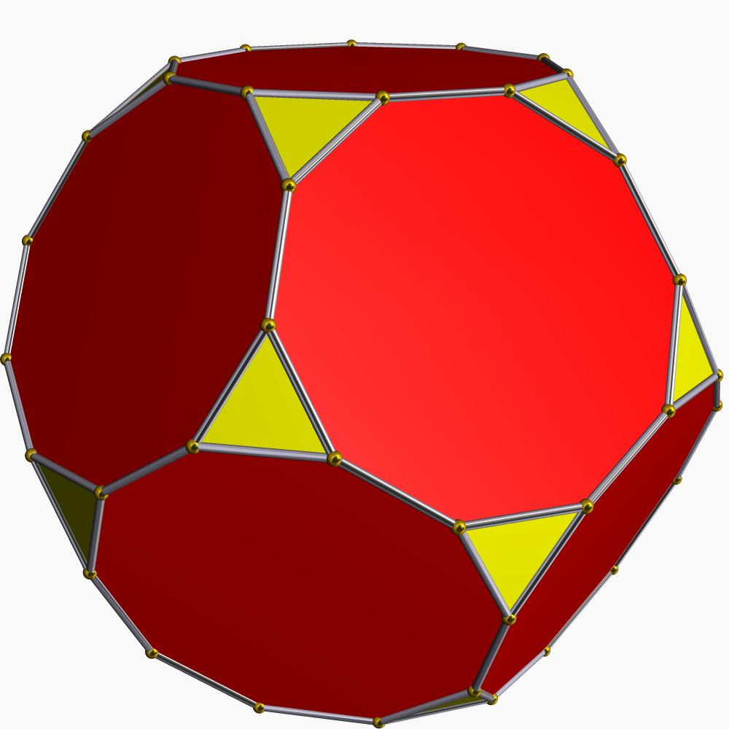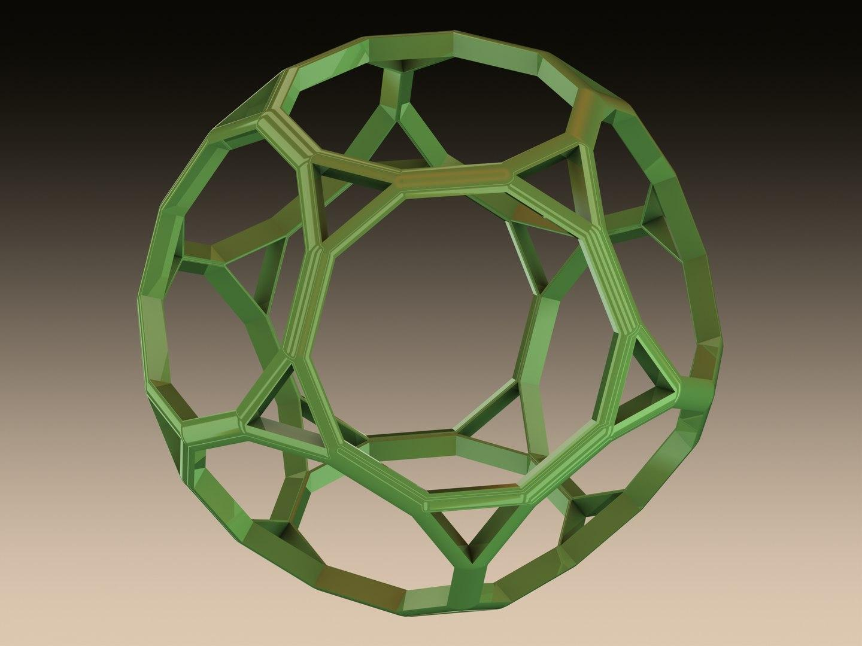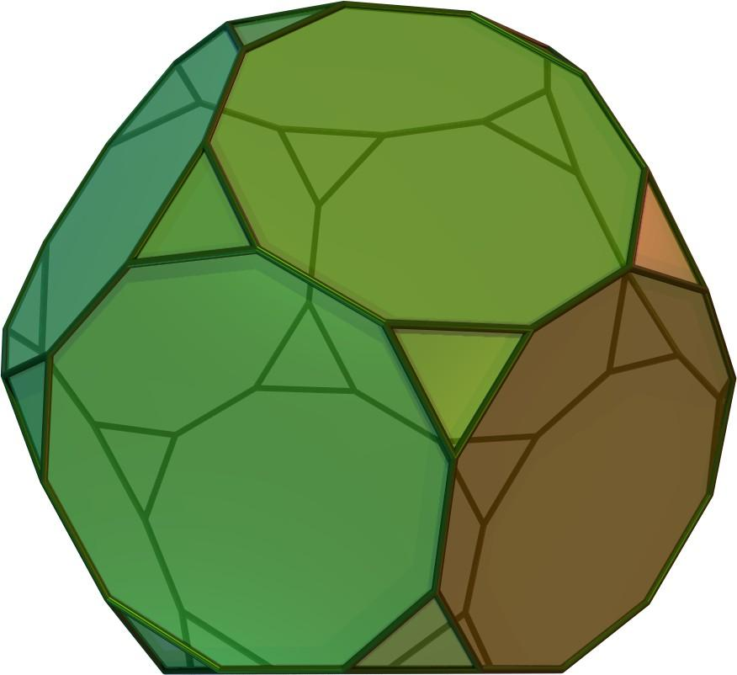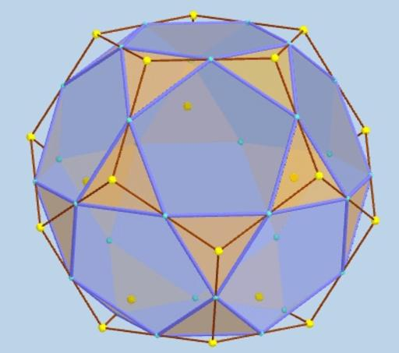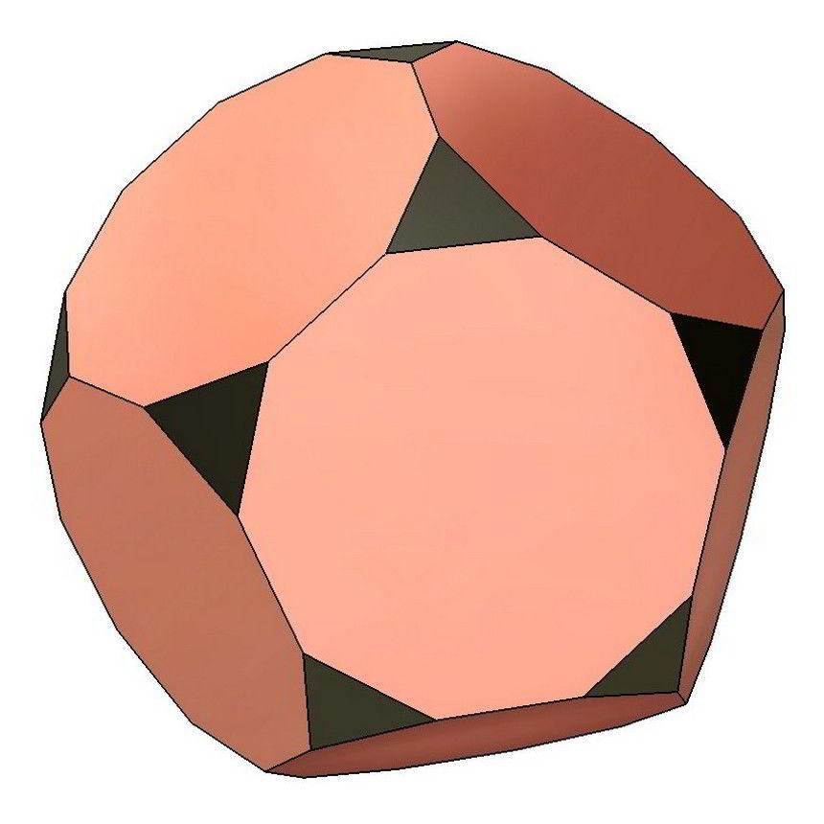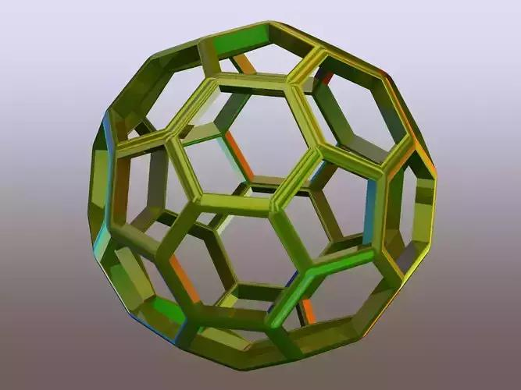

Definition
# Source: AI Source: Provided by: [Data Path: Persons Table -> ID Column: 1, Name_En Column: Motasem Essam] -> From: [ChatGPT] on [7/25/2026]
A Truncated Dodecahedron is a three-dimensional polyhedron formed by cutting off the twenty vertices of an original dodecahedron using planes.
The truncation process creates new triangular faces while modifying the original pentagonal faces into decagons.

Geometric Characteristics
# Source: AI Source: Provided by: [Data Path: Persons Table -> ID Column: 1, Name_En Column: Motasem Essam] -> From: [ChatGPT] on [7/25/2026]
- Original Solid: Dodecahedron
- Original Vertices: 20
- New Faces: 20 triangles and 12 decagons.
- Total Faces: 32
- Total Edges: 90
- Total Vertices: 60

Face Structure
# Source: AI Source: Provided by: [Data Path: Persons Table -> ID Column: 1, Name_En Column: Motasem Essam] -> From: [ChatGPT] on [7/25/2026]
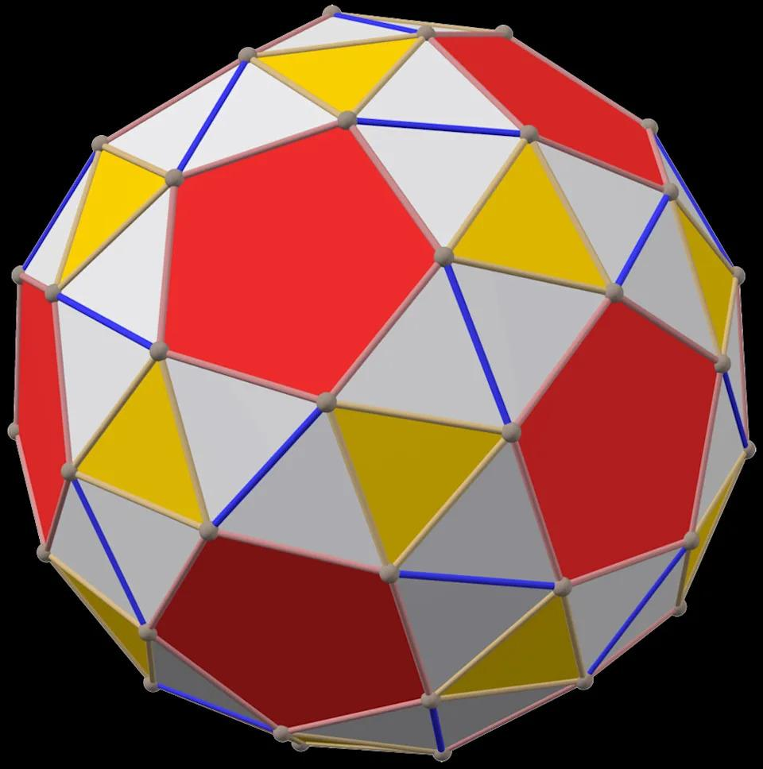
The truncated dodecahedron consists of:
- 20 Triangular Faces: Created by cutting off the twenty original vertices.
- 12 Decagonal Faces: Obtained by modifying the twelve original pentagonal faces of the dodecahedron.

Mathematical Properties
# Source: AI Source: Provided by: [Data Path: Persons Table -> ID Column: 1, Name_En Column: Motasem Essam] -> From: [ChatGPT] on [7/25/2026]
Let:
- $F$ = Number of faces
- $E$ = Number of edges
- $V$ = Number of vertices

Number of Faces
# Source: AI Source: Provided by: [Data Path: Persons Table -> ID Column: 1, Name_En Column: Motasem Essam] -> From: [ChatGPT] on [7/25/2026]
$$F=20+12=\boxed{32}$$

Number of Edges
# Source: AI Source: Provided by: [Data Path: Persons Table -> ID Column: 1, Name_En Column: Motasem Essam] -> From: [ChatGPT] on [7/25/2026]
$$E=\boxed{90}$$

Number of Vertices
# Source: AI Source: Provided by: [Data Path: Persons Table -> ID Column: 1, Name_En Column: Motasem Essam] -> From: [ChatGPT] on [7/25/2026]
$$V=\boxed{60}$$

Euler's Formula
# Source: AI Source: Provided by: [Data Path: Persons Table -> ID Column: 1, Name_En Column: Motasem Essam] -> From: [ChatGPT] on [7/25/2026]
For a convex polyhedron:
$$V-E+F=2$$
Substituting:
$$60-90+32=2$$
$$\boxed{2=2}$$
Therefore, the truncated dodecahedron satisfies Euler's formula.

Constructing Truncated Dodecahedron in Solid Geometry

Instruments Used
# Source: AI Source: Provided by: [Data Path: Persons Table -> ID Column: 1, Name_En Column: Motasem Essam] -> From: [ChatGPT] on [7/25/2026]
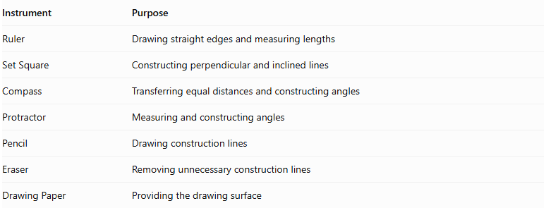
Instrument | Purpose
Ruler | Drawing straight edges and measuring lengths
Set Square | Constructing perpendicular and inclined lines
Compass | Transferring equal distances and constructing angles
Protractor | Measuring and constructing angles
Pencil | Drawing construction lines
Eraser | Removing unnecessary construction lines
Drawing Paper | Providing the drawing surface

Construction Procedures

A. Original Dodecahedron-Based Construction
# Source: AI Source: Provided by: [Data Path: Persons Table -> ID Column: 1, Name_En Column: Motasem Essam] -> From: [ChatGPT] on [7/25/2026]
This method starts with a regular dodecahedron and transforms it into a truncated dodecahedron.
- Draw a regular dodecahedron using an appropriate pictorial representation.
- Identify its 20 vertices.
- Mark equal truncation distances along the three edges meeting at each vertex.
- Connect the three marked points around each original vertex to form a triangular cutting boundary.
- Repeat the procedure at all 20 vertices.
- Remove or visually suppress the original corner regions.
- Identify the twelve remaining decagonal faces.
- Darken the visible edges and distinguish hidden edges.
- Check that the resulting model contains 20 triangular faces and 12 decagonal faces.

B. Edge-Based Construction
# Source: AI Source: Provided by: [Data Path: Persons Table -> ID Column: 1, Name_En Column: Motasem Essam] -> From: [ChatGPT] on [7/25/2026]
- Draw the original regular dodecahedron.
- Mark equal truncation distances along its 30 edges.
- Each original edge receives two truncation marks, one near each endpoint.
- Connect the appropriate marks around each original vertex to create 20 triangular faces.
- Connect the remaining points on the original pentagonal faces to form twelve decagonal faces.
- Refine the final solid representation.

C. Face-Based Construction
# Source: AI Source: Provided by: [Data Path: Persons Table -> ID Column: 1, Name_En Column: Motasem Essam] -> From: [ChatGPT] on [7/25/2026]
- Draw the twelve pentagonal faces of the original dodecahedron.
- Mark truncation points along the five edges of each pentagonal face.
- Connect the marked points to form a decagonal boundary inside each original pentagonal face.
- Construct the twenty triangular faces between adjacent decagonal faces.
- Join the face boundaries into one continuous polyhedron.

D. Net-Based Construction
# Source: AI Source: Provided by: [Data Path: Persons Table -> ID Column: 1, Name_En Column: Motasem Essam] -> From: [ChatGPT] on [7/25/2026]
- Draw a net containing twenty regular triangles and twelve regular decagons.
- Arrange the faces so that their shared edges correspond correctly.
- Add tabs if the net will be used for physical assembly.
- Cut out the net.
- Fold along the shared edges.
- Join the corresponding edges to form the truncated dodecahedron.
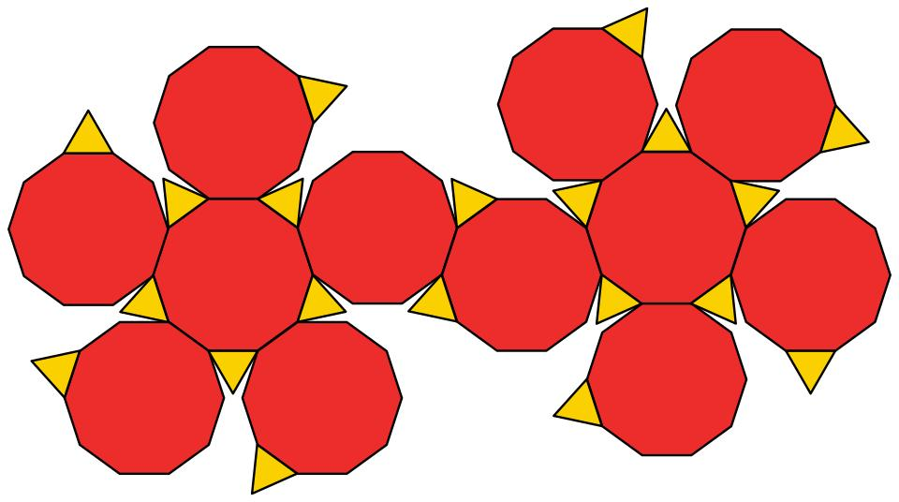

Key Points
# Source: AI Source: Provided by: [Data Path: Persons Table -> ID Column: 1, Name_En Column: Motasem Essam] -> From: [ChatGPT] on [7/25/2026]
- It is formed by truncating the twenty vertices of a dodecahedron.
- It has 20 triangular faces and 12 decagonal faces.
- It has 32 faces, 90 edges, and 60 vertices.
- Each original vertex produces one new triangular face.
- Each original pentagonal face becomes a decagonal face.
- It is an Archimedean solid when uniformly truncated.

Conclusion
# Source: AI Source: Provided by: [Data Path: Persons Table -> ID Column: 1, Name_En Column: Motasem Essam] -> From: [ChatGPT] on [7/25/2026]
The truncated dodecahedron is a three-dimensional geometric solid obtained by cutting off the twenty vertices of a regular dodecahedron. It consists of twenty equilateral triangles and twelve regular decagons, creating a symmetrical solid with 32 faces, 90 edges, and 60 vertices.

